**Semester: V (2023-24) Subject:** Communication Networks

**Name: Class:**

**Roll No: Batch:**

**Experiment No: 04**

**Name of the Experiment**: Study of advanced network with router and switches by using GNS3 simulator.

**Performed on:**

**Submitted on:**

**Aim:** To study advanced networks with router and switches by using GNS3 simulator.

**Pre Requisite:**  Basic knowledge of network components and its working principle.

**Objective:**

* To study GNS3 network simulator.
* To simulate switches and routers to the network using GNS3.

**Components and equipment required/studied:**

* Computer with GNS3 software installed on the system (preferably Windows).

**Theory:**

The Graphical Network Simulator-3 is an open source, free network software emulator that is used by over one million network engineers, students, and architects all over the world to simulate, configure, test, and troubleshoot virtual and real networks.

* When building a new enterprise network, it can be useful to simulate the network before going live. A simulation allows for better testing and troubleshooting, as well as creating different models to find the one that is most effective for the desired need.
* GNS3 that allows simulation of complex networks. You may be familiar with VMware or Virtual PC that are used to emulate various operating systems in a virtual environment.
* During this process, you need to create network devices and host them on the server process. In principle, the server component can be executed as a local virtual machine (VM) and as a remote VM
* The software allows users to simulate a wide range of networks, from running a small topology that consists of only a few devices on your laptop, to those that consist of many devices hosted on multiple servers or in the cloud.

GNS3 supports many devices from various network vendors including Cisco virtual switches, Cumulus Linux switches, Cisco ASAs, Brocade vRouters, HPE VSRs, Docker instances, multiple Linux appliances and many others.

**Procedure:**

1. Open GNS3 and enter name of new project
2. On the left-hand side of the screen browse to Router option and select a router IOS image (preferably c1700). Drag two routers on the screen.
3. For switch selection, browse to the switch section and choose two switches.
4. Browse to End devices to select VPCS.
5. To make connections, click on Add a link option on left-hand side and execute the following steps:
6. Click on PC1, select Ethernet0/0 then drag to Switch 1.
7. Make connection from Switch 1 to Router 1 and select Ethernet 0/0 option.
8. Repeat the steps 1 and 2 for PC2, Switch 2 and Router 2.
9. Make a connection between Router 1 and Router 2, and select FastEthernet 0/0 option.

6) Open Console from Menu bar.

7) Assign IP address to the PC1 and PC2.

8) Assign IP address to Router 1 and Router 2.

9) Similarly, we need to configure all the devices. Once it is done, we can check whether the network is correctly configured or not by using the ping command at different interfaces or by pinging from one PC to another PC.

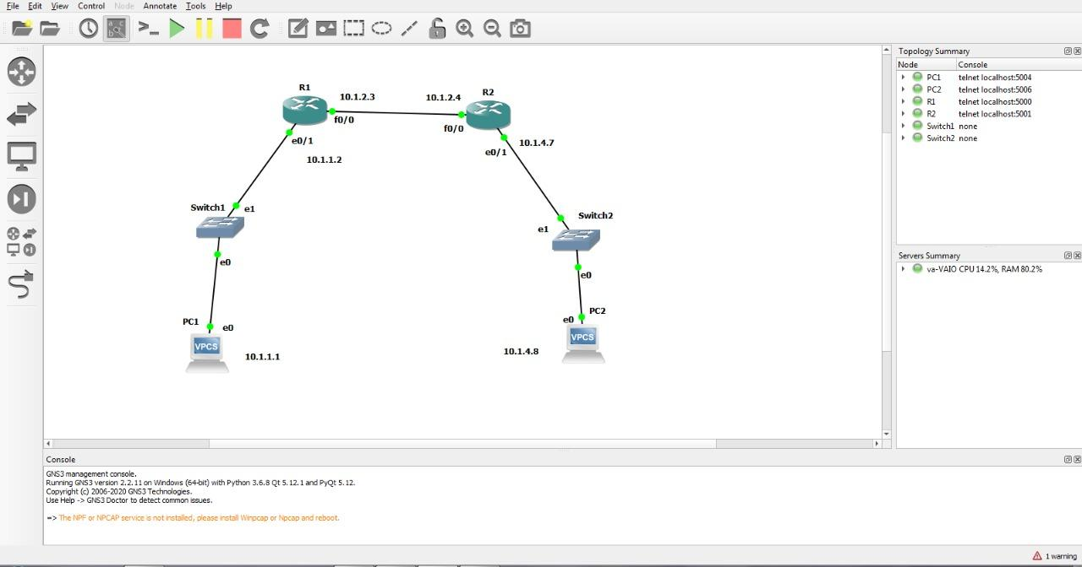

**Add min 4 – 5 screen shots**

**Add commands and related process**

**Conclusion:**

**Post Lab Questions:**

1. Why the switch is not assigned with an IP Address?
2. Why is 255.255.255.0 written while assigning IP Address to Router?
3. How do you check whether the configuration is correct or not?
4. How can we use Wireshark for capturing the packet on GNS3?